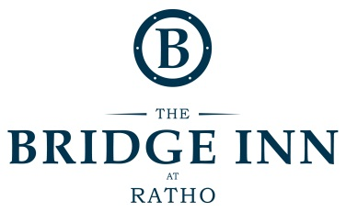
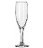
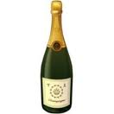
WINE LIST
 |  |  |  |  |  |  |  | 125ml | Btl
CHAMPAGNE AND SPARKLING WINES
PROSECCO Cadi Alti (Pradio, Italy) |  |  |  |  |  |  |  | 4.00 | 24.00
CHAMPAGNE Charles Heidseck NV Brut (Champagne, France) |  |  |  |  |  |  |  | 9.50 | 54.50
CHAMPAGNE Charles Heidseck NV Rose (Champagne, France) |  |  |  |  |  |  |  | 9.95 | 59.50
 |  |  |  |  |  |  |  |  | 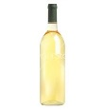
 |  |  |  |  |  |  | 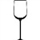 | 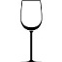
 |  |  |  |  |  |  | 175ml | 250ml | Btl
WHITE WINES
TREBBIANO/GARGANEGA Ponte Pietra (Umbria, Italy) |  |  |  |  |  |  | 3.75 | 5.00 | 15.00
CHARDONNAY Piemonte (Piemonte, Italy) |  |  |  |  |  |  | 4.90 | 6.50 | 17.50
SAUVIGNON BLANC Touraine (Loire, France)  PINOT GRIGIO Alpha Zeta (Verona, Italy)  CHENIN BLANC Cannonberg (Western Cape, South Africa) |  |  |  |  |  |  | 5.00  5.15  5.20 | 6.70  6.80  6.90 | 19.00  19.50  20.00
GERWURTZTRAMINER Emiliana (Adobe, Chile) |  |  |  |  |  |  | 5.50 | 7.25 | 21.50
ALBARINO Finca Arantei (Galicia, Spain) |  |  |  |  |  |  | 5.60 | 7.80 | 23.00
RIESLING Dr.Loosen (Mosel, Germany)  CHARDONNAY Macon-Uchizy (Burgundy, France)  VIOGNIER Tabali (Limari Valley, Chile) |  |  |  |  |  |  | 6.10  6.25  6.35 | 8.25  8.50  8.65 | 24.00  24.50  25.00
GAVI DI GAVI Lugarara (Piedmont, Italy) |  |  |  |  |  |  | 7.25 | 9.50 | 28.00
RIESLING Tinpot Hut (Marlborough, New Zealand) |  |  |  |  |  |  | 7.50 | 9.80 | 29.00
CHABLIS Laroche (Burgundy, France) |  |  |  |  |  |  | 7.50 | 9.80 | 29.00
SAUVIGNON BLANC Greywacke (Marlborough, New Zealand) |  |  |  |  |  |  | 8.00 | 10.30 | 30.00
ROSE WINES
TEMPRANILLO/SHIRAZ Plot 22 (Gijon, Spain) |  |  |  |  |  |  | 4.00 | 5.50 | 16.00
MERLOT/CAB FRANC Chateau De Sours (Bordeaux, France) |  |  |  |  |  |  | 6.25 | 8.50 | 23.00
 |  |  |  |  |  |  |  |  | 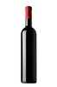
 |  |  |  |  |  |  | 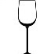 | 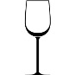
RED WINES |  |  |  |  |  |  | 175ml | 250ml | Btl
MERLOT/SANGIOVESE Brume di Monte (Venice, Italy) |  |  |  |  |  |  | 4.00 | 5.40 | 15.50
CARIGNAN Mont Rocher (Languedoc, France) |  |  |  |  |  |  | 4.25 | 5.60 | 16.50
SHIRAZ Longbeach (Western Cape, South Africa) |  |  |  |  |  |  | 4.50 | 6.20 | 17.50
CABERNET SAUVIGNON Excelsior (Robertson, South Africa) |  |  |  |  |  |  | 4.90 | 6.80 | 20.00
MERLOT Nostros Gran Reserva (Casablanca, Chile) |  |  |  |  |  |  | 5.50 | 7.50 | 21.50
PINOT NOIR Soli (Thracian Valley, Bulgaria)  SYRAH/CARIGNAN Mas Des Amours (Languedoc, France) |  |  |  |  |  |  | 6.10  6.10 | 8.30  8.30 | 24.00  24.00
RIOJA CRIANZA Ontanon (Rioja, Spain) |  |  |  |  |  |  | 6.50 | 8.50 | 25.00
BORDEAUX Chateau Cissac (Haut Medoc, France) |  |  |  |  |  |  | 7.25 | 9.50 | 28.00
FLEURIE Lucien Lardy (Beaujolais, France) |  |  |  |  |  |  |  | 10.30 | 30.00
MALBEC Felino (Mendoza, Argentina) |  |  |  |  |  |  |  | 11.00 | 32.00
SHIRAZ Block 8 (New South Wales, Australia) |  |  |  |  |  |  |  | 12.95 | 37.50
BAROLO Bric Sorej (Barolo, Italy) |  |  |  |  |  |  |  | 15.25 | 45.00
VALPOLICELLA Ferragu (Verona, Italy) |  |  |  |  |  |  |  | 16.75 | 50.00

