SANTA BREAKFAST ENQUIRY FORM 2020

Date and Time
Name
Telephone
Email
Number of adults
Number of children

Age of children
Names of children
Number of pancakes | Adult | Child
Number of cooked breakfasts | Adult | Child
Dietary and other requirements
£15 per person
12/12 – 10am
13/12 – 10am

19/12 – 10am
20/12 – 10am

Breakfast options
Homemade pancakes with maple syrup
OR
Cooked
Scottish breakfast

HEADS UP!
There are only 40 places available per sitting. This is a
request form not a
guaranteed booking.
EACH TABLE CAN ONLY BE A
MAXIMUM OF 6
GUESTS AND 2
HOUSEHOLDS

Please fill in as us much information as you can and send to info@bridgeinn.com

Payment will not be taken for your booking until the start of
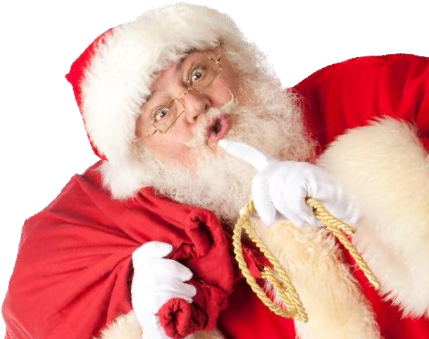
December. One of our elves will be in touch with you to take payment on the 1st of December.

